Biology 115d Schulze 2023

**Evolution, Behavior, & Ecology Quiz #2**

**Name (printed) _____________________________________**

**This work was completed in accordance with the Austin College academic integrity policy.**

**______________________________________ (signature)**

**(If submitting an electronic version by email, simply indicate whether you have cheated on this exam. You don’t need to find a way to add your signature.)**

° Read each question carefully.

° If a question appears ambiguous, ask for clarification.

° Keep an eye on the clock. Do not get bogged down on difficult questions when relatively easy questions remain to be answered.

° Write legibly and try to confine your answers to the space provided. If you must have more space, continue elsewhere on the exam – but indicate that you have done so.

° Written answers should explain reasoning or evidence, not simply make unsubstantiated claims.

-----

1. Use the following terms to define inbreeding depression and explain the cause and effect circumstances that result in inbreeding depression. Terms: recessive, mutation, fitness, homozygous, allele, recent ancestor. Plan your answer before beginning to write. I recommend that you plan your answer and then make sure it uses the terms rather than start with the terms. Use any other terms you find helpful. Check your answer for completeness (inclusion of all key cause and effect processes) (6 points).

“Inbreeding” means mating among close relatives. “Inbreeding depression” refers to reduced individual fitness because of inbreeding. Inbreeding depression results because of the following circumstances. 1. Mutations are common, but any given mutation is extremely unlikely. 2. Every carrier expresses harmful dominant mutations in their phenotype, so such mutations are consistently selected against and quickly eliminated from gene pools, but harmful, recessive mutations are almost never expressed in the phenotype because any given mutation is rare, so two mates that are not closely related are extremely unlikely to carry an allele with the same mutation. 3. Because harmful recessive alleles are not normally selected against, they accumulate in populations. We all carry many hidden in heterozygotes. 4. If two closely related individuals mate, they will have both inherited one or more of the same harmful recessive alleles from their recent common ancestor, and therefore may both pass on the same recessive harmful allele to offspring. When those offspring receive two copies of such an allele (are homozygous for the mutation), the mutation will affect the phenotype and the fitness of those individuals will be reduced compared to outbred individuals.

(If a population is tiny and comprised entirely of related individuals, inbreeding depression may be unavoidable, but you did not need to explain this to receive full credit.)

Multiple Choice Questions. Choose the single best answer. *Do not select 2 or more answers. 2 points each.*

2. Which of the following is not true?

___ Most mutations are inconsequential (do not affect fitness) or harmful to fitness.

___ Mutations occur randomly.

___ Mutations occur when a species needs to adapt to new environmental circumstances.

___ Any particular mutation is extremely unlikely.

___ A mutation is a change in a DNA sequence that alters an allele.

___ Mutations are the source of brand new genetic variation.

3. The example of bill depths of the finch species *Geospiza fortis* on Daphne Island (that we discussed in class and you studied in a simulation)

___ provides an example of directional selection.

___ provides an example of sexual selection.

___ provides an example of inbreeding depression.

___ all of the above.

___ none of the above.

4. I used the *New York Times* puzzle with the sequence of numbers 2, 4, 8 as a means of emphasizing the key feature of science done well because

___ both are based in math and all important scientific questions are mathematical.

___ you can run experiments to solve the puzzle and to do scientific research.

___ progress in both the puzzle and science is based on looking for evidence consistent with a hypothesis.

___ progress in both depends on seeking evidence that an idea is wrong.

___ none of the above.

5. The key evidence that the Bajau have undergone selection for breath holding behavior is

___ their spleens are larger than their inland neighbors, the Saluan.

___ a favorite game of their children is to see who can hold their breath the longest.

___ they can see clearly when they open their eyes in seawater, whereas the view would be blurry for most people.

___ they select their leaders on the basis of breath holding and deep free diving (diving while holding one’s breath) ability.

___ All of the above.

___ None of the above.

(continued on next page)

6. Which is most likely to increase the genetic diversity of a population?

___ sexual selection

___ gene flow

___ genetic drift

___ a bottleneck event

___ all of the above

___ none of the above

7. Which of the following does not represent an example of convergent evolution.

­­­___ bird and bat wings.

___ octopus and human eyes.

___ whale and shark shapes.

___ dog and human forelimb bones.

___ all of the above. (In other words, none of the above are examples of convergent evolution).

___ none of the above. (In other words, all of the above are examples of convergent evolution.)

8. Indicate which of these is a bimodal distribution?

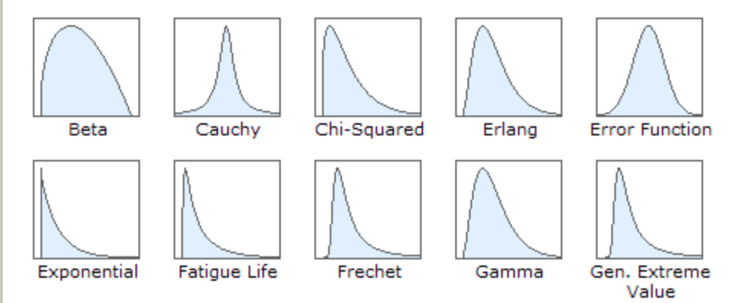

A

B

C

D

E

F

G

H

I

J

K All of the above

L None of the above